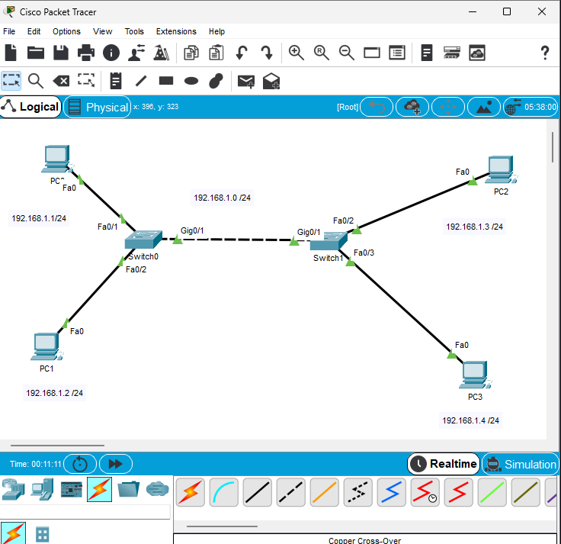

Perfect PAMSY 🙌 — let’s rewrite your explanation clearly and correctly:

✅ Corrected Answer
When PC1 pings PC3:
- Step 1 — ARP Request (Broadcast)
  - PC1 needs PC3’s MAC address but doesn’t know it yet.
  - PC1 sends an ARP request: “Who has IP 192.168.1.3? Tell me your MAC.”
  - This ARP request is sent as a broadcast frame with destination MAC = FF:FF:FF:FF:FF:FF.
  - All devices in the LAN (PC2, PC3, PC4, SW1, SW2) receive the broadcast.
- Step 2 — ARP Reply (Unicast)
  - Only PC3 recognizes its own IP in the request.
  - PC3 replies with its MAC address.
  - This reply is a unicast frame sent directly to PC1 (destination = PC1’s MAC).
  - Other PCs (PC2, PC4) do not process this reply.
- Step 3 — Ping (ICMP Echo Request/Reply)
  - Now PC1 knows PC3’s MAC.
  - PC1 sends the ping (ICMP Echo Request) as a unicast frame to PC3.
  - PC3 responds with an ICMP Echo Reply, also unicast back to PC1.
- Step 4 — Switch MAC Table Learning
  - As frames travel through SW1 and SW2, each switch learns the source MAC addresses and stores them in its MAC address table.
  - This way, future traffic is forwarded directly without broadcasting.

📝 Key Points
- Broadcast (ARP Request) → received by everyone, but only PC3 replies.
- Unicast (ARP Reply + Ping) → exchanged only between PC1 and PC3.
- Switches learn MACs dynamically during this process.
- • The ARP request/reply happens at Layer 2 (Data Link) because it deals with MAC addresses.
- • The ICMP echo request/reply happens at Layer 3 (Network) because it uses IP addresses.
- • Both are encapsulated into Ethernet frames at Layer 2 when sent across the physical network.
- • ARP = Layer 2 (Data Link)
- • ICMP Echo Request/Reply = Layer 3 (Network / Internet Layer in TCP/IP)

